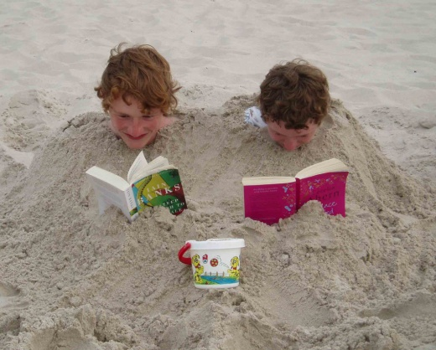
Extreme Reading Competition
Get caught reading in an unusual place...take a picture and send it to homework@haresfield.gloucs.sch.uk
Parents are welcome to join in!
There will be prizes for the winning entries and we will share all your images in a special worship and on the website.

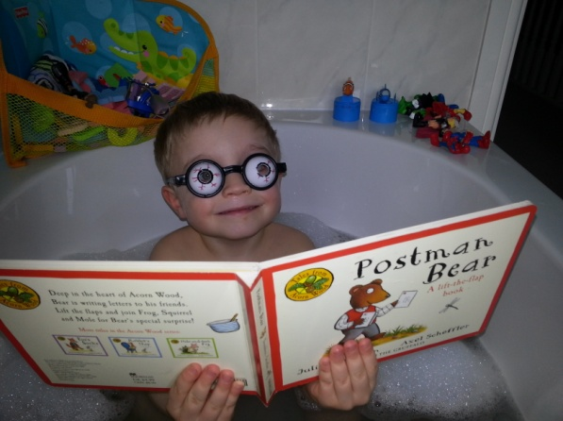

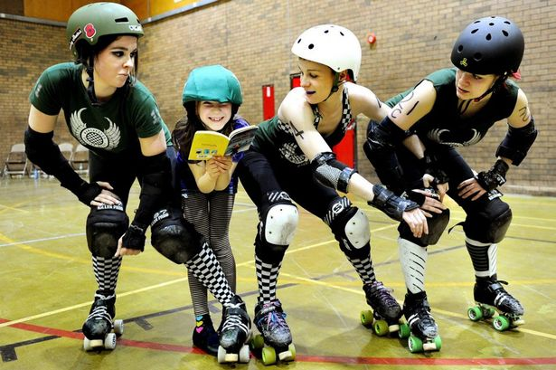
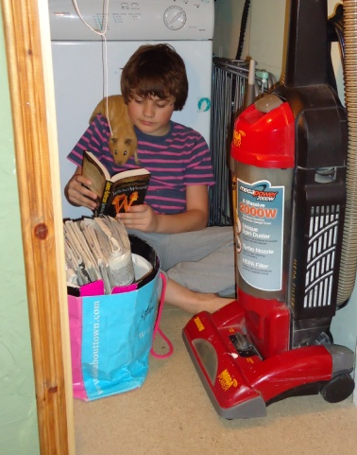
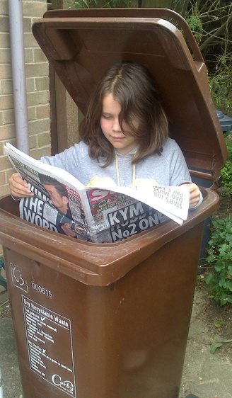

Please remember to STAY SAFE and ask an adult to help you.
Closing date: 29th January 2016

